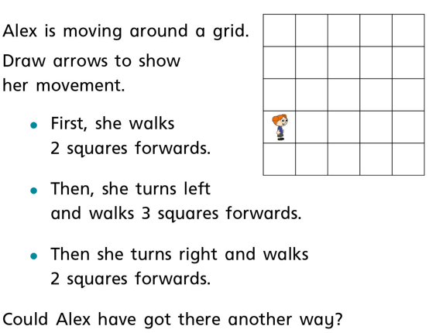
Can you follow the written directions and plot the route Alex moves on the squared paper?

