Learning Project: Summer Term (22.6.20) – Sport

The project this week aims to provide opportunities for
your child to learn more about Sports.

The activities for this project are designed for the whole family. We do not expect you to complete all of the activities. Please choose the activities that interest your family and complete these throughout the week. If you would like to share this learning with your teacher, you can upload it onto Tapestry, Purple Mash or email it to school. You can also continue to contact your teacher through Purple Mash, Tapestry and e-mail

This symbol shows that the activity has been set and can be handed in on
Purple Mash (although you can use paper/card instead if you prefer).

Please look at Tapestry, Purple Mash and the school website for English and Maths activities
Activities:
Start the topic by finding out what the children already know about sport
Can your child talk about all the different sports and physical activities they know? Can they have a go at writing them in a list (i.e. run, jump, skip, football, hockey, tennis)?

Watch and listen
Watch the Large Family sports day https://www.youtube.com/watch?v=DS1c4jQT9nY
Listen to a sporty story https://www.bbc.co.uk/cbeebies/radio/story-time-martin-the-mouse
Watch The little princess I want to win https://www.youtube.com/watch?v=fZS48tXYgK4

Talk about what was similar or different in each of the stories. Think about how each of the characters felt in the stories when they were winning or losing. Can you think of a time when you might have felt like that?

Favourite sporting activity
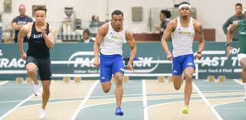
Ask your child to draw a picture of themselves doing something sporty. i.e. running, jumping, a cartwheel. Can they label the picture or write a simple sentence e.g. I can hop.

Go noodle
Try a new dance routine or calming meditation on go noodle. There is so much to choose from. https://family.gonoodle.com/

Write a Newspaper report
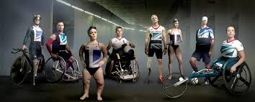
With an adult use the internet to research Paralympians and choose one to write about in a newspaper report. What sport did they take part in? Which country did they represent? Did they win any medals? How did they feel during the paralmpics? How did they get into their sport?
Sporting hero
Does your child have a favourite sportsperson? This could be their P.E. teacher!
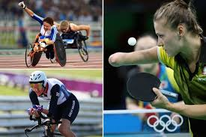
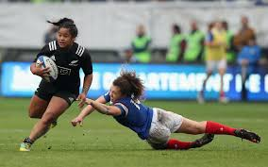
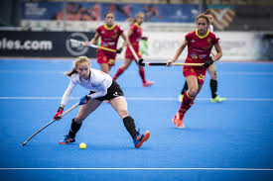
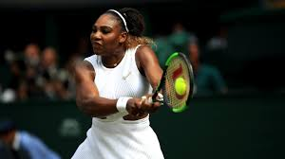
Ask them to write an information booklet about this person.

Ball games
Play a game of catch with a ball - when you drop the ball, you lose a point. You could record points using a tally chart and count up who has the most points at the end.
CHALLENGE: See if you can catch the ball standing further apart, catch with one hand or use a smaller ball

Question time
Ask your child to think of questions they’d love to ask their favourite athlete. They could write a list of questions using a range of questions words such as ‘when’, ‘ why ’, ‘ who ’, ‘ what ’, ‘ where ’ and ‘ how ’. Your child could then answer their own questions in the role as their hero.

Make your own junk modelled sports pitch
Using a lid of a shoe box or similar container, help your child to cut out two holes on each end as the goals. If you have green card or paper, stick this in the base, if not you can colour in plain paper using a crayon. Draw out the markings on the pitch using
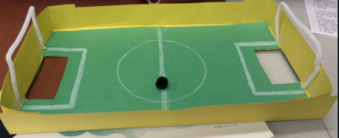
crayons or felt tips. When finished, stand your football pitch on a box on the table. Using something ball-like, take turns aiming at your partner’s goal whilst
the other tries to save the goal.

Challenge – write instructions to play your game.

Obstacle Course Fun
Task your child with designing and making their very own obstacle course in the garden. Ask them to draw and label their design first and include all of the equipment they need. They can then use their design to create their obstacle course. Ask the family to complete the obstacle course whilst your child times them. Your child could even make medals from tin-foil or any other suitable material and present them to the winner during a winner’s ceremony.

Make a Family Mascot
Your child could make their very own family mascot using materials from around the house. First of all, visit the Olympic Mascot Official list here https://www.olympic.org/mascots
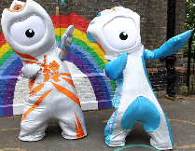
and look at past mascots. What makes a good mascot?
What qualities does the mascot represent?

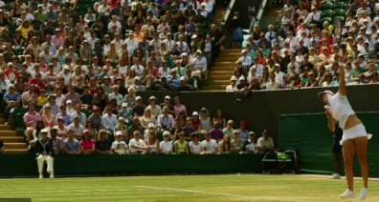
Wimbledon crowd
Can you draw the spectators at Wimbledon?

Remarkable Routines- Can your child create their very own simple routine, just like a gymnast, dancer or synchronised swimmer? Start by watching a video of
a routine together, here are some suggestions:, synchronised swimming routine https://www.youtube.com/watch?v=7r3M4_-yp6U .
Men’s gymnastic floor routinehttps://www.youtube.com/watch?v=drvXbzZHV9I

After this, your child can choose a piece of music to practise their routine to. You might need to help them choose safe moves.
Watch the performance together- what does your child think went well? What could be even better?
Terrific Team Kits- Ask your child to design their very own team kit. They should consider the flag of the country that they would represent and how to incorporate these colours into the design. They could draw the design with a pencil or use a computer program to do this.
Can you Invent a New Olympic Game? - Challenge your child to invent their very own game for the 2021 Olympics. Look at a list of all of the sports that already compete in the summer Olympics here. https://www.olympic.org/sports Can they write a set of instructions for the new game or draw illustrations. Why not test the game out as a family?

Change 4 life
NHS Change 4 Life website has some great games and activities, specifically ones for staying indoors. Have a look. https://www.nhs.uk/change4life/activities/sports-and-activities

Jumpstart Jonny
Join Jumpstart Jonny for some high energy work outs.
https://www.jumpstartjonny.co.uk/free-stuff

Yoga
Relax with cosmic kids yoga
https://www.youtube.com/user/CosmicKidsYoga

Medals
Design your own winner’s medal.

Purple Mash
As well as the activities above which we have set there are lots of other sports reports, designing and colouring activities that can be done on Purple mash. Just type sport into the search bar and choose your activity. Have fun!

