Learning Project: Summer Term Week 7 (w/c: 1.6.20) – Celebrations

The project this week aims to provide opportunities for your child to learn more about different celebrations. This week’s learning may focus on the different types of celebrations that take place and who may celebrate them. It will look at how people celebrate different events in other parts of the world.

The activities for this project are designed for the whole family. We do not expect you to complete all of the activities. Please choose the activities that interest your family and complete these throughout the week. If you would like to share this learning with your teacher then you can upload it onto Tapestry, Purple Mash or email it to school.

You can also continue to contact your teacher through Purple Mash, Tapestry and e-mail.

This symbol shows that the activity has been set and can be handed in on
Purple Mash (although you can use paper/card instead if you prefer).

Please look at Tapestry, Purple Mash and the school website for English and Maths activities.

Activities:
Family Photographs

Look over a selection of photographs of family celebrations and discuss with your child: what the celebration was about, who attended, what you did to celebrate, when it took place, whether it is an event that happens each year. Can your child remember the event taking place? What do they remember of it?

Plan a family celebration

- Decide on a family celebration for this week. This could be in the form of a family indoor picnic, meal, dance etc. Ask your child to write invitations to family members to the party. Talk about how they feel when they are looking forward to an event.
- Design and make a card for your celebration or occasion.
- Create homemade decorations using coloured paper (If you do not have coloured paper at home, you could use old newspaper or wrapping paper) You could make paper chains or bunting
- Plan a menu for the party and make the food together.
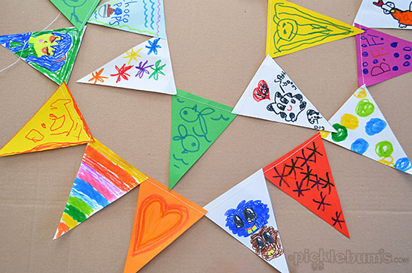
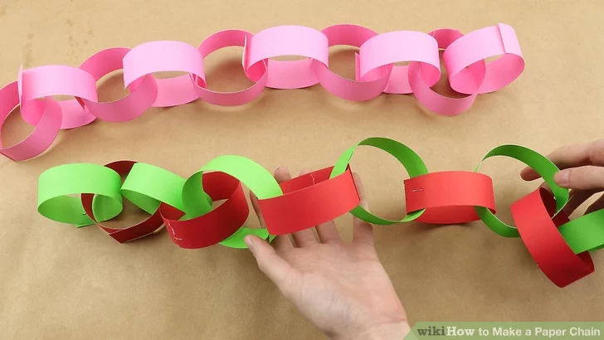
Discover religious celebrations

- Remind the children of the recent events of Easter or V.E. day. Discuss them with your child. Can they remember how they celebrated eg Easter? Talk about how they felt when they were preparing for the event, what did they enjoy most? Why?

- Find the Let’s Celebrate videos collection on CBeebies and watch some together. Discuss who celebrates the event and talk about any similarities and differences with celebrations your child has taken part in.

Birthdays

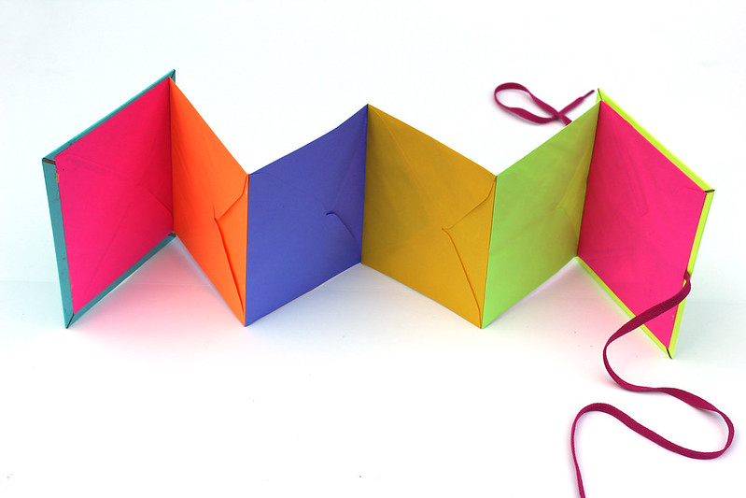
Talk to your child about when they were born. Look at photographs of the day they were born, if you have them available. Do they know the date of their birthday? Support your child to create an all about me folding book (as pictured) with their birth date, current age and anything else they think is important for people to know about them.

Celebrations

- Type in ‘Events and Celebrations’ in the search bar of Purple Mash and explore the many ‘Paint’ activities that are linked to a variety of celebrations such as:
-Design your own birthday or wedding cake
-Design a poppy for Remembrance Sunday
-Design a Harvest basket of food
-Create a night sky of colourful fireworks
-Decorate a Chinese fan
Faiths

- Type in Celebrations and Faith in the search bar to find out about different Faiths, such as: Christianity, Hinduism, Islam, Sikhism, Buddhism or Judaism. Can they talk about similarities and differences between each Faith?

Get Creative!

- Make and decorate your own Chinese fan or lantern.
- Design And draw your dream birthday cake or a wedding cake or dress
- Draw round your hand, cut it out and then decorate it with Mehndi patterns
- Draw and label a plate of your favourite celebration food.
- Use an empty toilet tube to make and decorate your own firework.
Party Games
- Play some of your favourite party games together such as:
-Pass the parcel
-Pin the tail on the donkey
-Musical statues
-Musical Bumps

Music
- Listen to some traditional music from different cultures.
- What songs do you sing at your family celebrations?

