Learning Project - Summer Term (29.6.20): Transport
The project this week aims to provide opportunities for your child to learn more about Transport. Press and hold ‘Control’ and then right click on the links in blue to take you to the linked websites. |  |  |  |  |  | 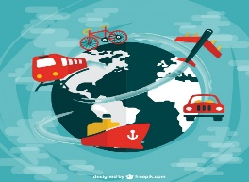
The activities for this project are designed for the whole family. We do not expect you to complete all of the activities. Please choose the activities that interest your family and complete these throughout the week. If you would like to share this learning with your teacher, you can upload it onto Tapestry, Purple Mash or email it to school. You can also continue to contact your teacher through Purple Mash, Tapestry and e-mail.

This symbol shows that the activity has been set and can be handed in on
Purple Mash (although you can use paper/card instead if you prefer).

Please look at Tapestry, Purple Mash and the school website for English and Maths activities.

Activities:
Start the topic by finding out what the children already know about transport. They could do this by creating a mind-map. If it helps, they could use books or the internet to search for and look at some themed images to prompt their thinking. Or, try listening to some transport themed sounds, either out of the window or using this YouTube clip. To help them focus on the sounds, the children could listen without looking at the images. Give them some paper and colouring pencils / chalks to draw what they think of when they listen to the music.
Read some stories with a transport theme, or listen to one online, e.g. The Train Ride, Mrs Armitage on Wheels and Whatever Next! If you haven’t already, you could also watch some other stories, read by some of your teachers, on our YouTube channel Duck in the Truck, The Smeds and the Smoos, and The Dinosaur that Pooped a Planet.
 |  | Traffic Survey:  Looking out from your window if you can, or from a safe place with an adult if not, can you keep a record of how many vehicles go past of each colour? You could record it using a tally chart or in any way you like. On Purple Mash, can you create a pictogram to show your results? (Set as a 2Do) |  |  |  |  |  |  | 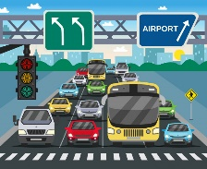
Explore some amazing machines:  Find out more about particular vehicles by watching some episodes of Catie’s Amazing Machines on CBeebies. Some particular episodes you might like are: Racing Machines, Emergency Machines, Underwater Machines, Fancy Machines and Amphibious Machines. |  |  |  |  |  |  |  |  |  | 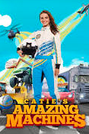
Terrific Transport:
Use a construction set (e.g. Lego) or junk modelling / craft items you have around your house to create your own vehicle. What will you make? What does your vehicle need to be able to do? How will you decorate the outside? Challenge: If your vehicle has wheels, how could you make them turn round when you push it?
Brilliant Boats:  Can you design and make a toy boat that will float? What does a boat need to be able to do? What will you use? What shapes might make the best boat? To help with the design, the children could experiment freely with materials found around the house in a sink filled with water, e.g. paper, yoghurt pots, tinfoil, cardboard tubes, plastic / foil tubs. Test your designs in water.  Challenge: How many pennies can your boat hold before it starts sinking? |  |  |  |  |  |  |  | 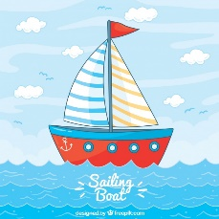
 | Simple City - Garage:  Use the Simple City app in Purple Mash to find out more about the role of a mechanic in a car garage. You can also design your own car and then drag and drop letters from the alphabet to label it. (Set as a 2Do). |  |  | 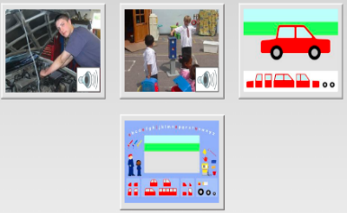
Design a vehicle for the future:  Can you design a car (or any vehicle) for the future? What will it be able to do? What materials will it be made from? How will it work? What speed will it be able to travel at? How much would it cost to buy? |  |  |  |  | 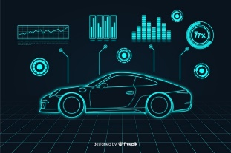
Coding activity:  Vist the website the j2code website. Use your programming skills to make the rocket land on different planets or try parking a car in different spots. For an introduction to what coding is, you can find information from BBC Bitesize: What is code? and What is an algorithm? |  |  |  |  | 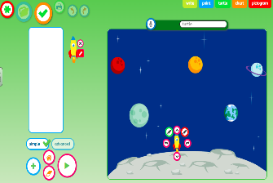
Transport through time:  Use books or the internet to research older versions of some transport. Choose one to study in more detail and create a document to show how it has been developed over the years. What features does it have? How have they changed? |  |  |  |  |  |  | 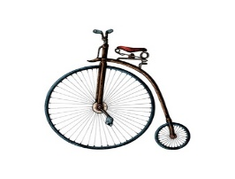
Transport across the world:
Reseach the different modes of transport in other countries, e.g. France, Mexico, India. Compare them to see which modes of transport we have in common. Why are some modes of transport more popular in some countries? You could look for the country on a map of the world (use Google Maps or search for one online if you don’t have a paper copy).
Paper Planes / Boats: Try making your own paper planes or boats. If you need some help, follow these links for step-by-step instructions… Perfect Paper Planes or How to make a paper boat.
Transport themed food ideas:
Follow the link for related ideas for transport themed food.
For a relaxing end to the week (or whenever needed!) Click here for some transport themed colouring (there are lots of other free ones you can print off the internet) or ask the children to draw and colour their own pictures of transport.

Images attributed to Freepik: https://www.freepik.com/

