Learning Project: Summer Term (8.6.20) – Under the sea

The project this week aims to provide opportunities for your child to learn more about Under the sea. Learning may focus on the under the sea habitat, what animals you may find there and the affects humans have on the oceans.

The activities for this project are designed for the whole family. We do not expect you to complete all of the activities. Please choose the activities that interest your family and complete these throughout the week. If you would like to share this learning with your teacher then you can upload it onto Tapestry, Purple Mash or email it to school.

You can also continue to contact your teacher through Purple Mash, Tapestry and e-mail.

This symbol shows that the activity has been set and can be handed in on
Purple Mash (although you can use paper/card instead if you prefer).

Please look at Tapestry, Purple Mash and the school website for English and Maths activities.

Activities:
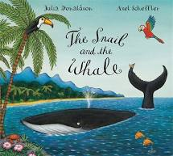
The Snail and the Whale - https://www.youtube.com/watch?v=usBHaMjviEI
Follow the link to listen to the story or watch the story here https://www.bbc.co.uk/iplayer/episode/m000cslw/the-snail-and-the-whale

Snail hunt – After listening to the story can you find a snail in your garden or on a walk.
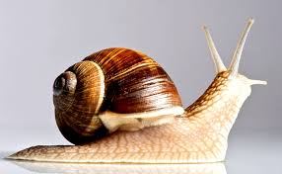
Where might the snail want to live? Why?
How are these snails the same or different to the sea snail?

Snail Race – If you find 2 or more snails you could have a snail race. Use chalk to draw out lines on the ground (or sticks to mark out the lines) to create a race track. Place your snails at the starting line and watch them go! You could use a timer to measure how long it takes for the snails to make their way across.

Remember to put the snails back after your races.

Snail Writing - Have a try at Snail Writing. Using hair gel, shaving foam or any other
slimy liquid, show your child how to form the letter ‘ s ’ using your finger. Can you write the word snail? What other words can you write?
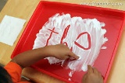
Underwater sea creature – Think about your favourite sea creature, can you draw a picture of it? Have a go at writing some labels or information about it too.

Junk Modelling - Using junk or recycling materials from around the home, ask your child to design and make a Sea Turtle or other sea creature.

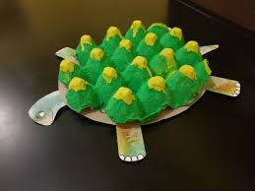
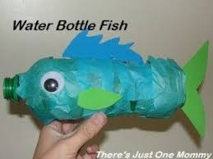

Put Your Goggles On - . https://www.youtube.com/watch?v=3VptlkY9lT8 Join Sam as she explores a ship wreck and Coral Reef. Find out about the shipwrecks and reefs. Whilst watching, can you sketch some of the animals that you see? Or write about what you have learnt.
Desert Island Visit a Desert Island here https://safeyoutube.net/w/Dxh6
Can you write a message in a bottle? What can you see, hear, taste, smell? Why not roll up your message and pop it in a plastic bottle to keep at home or share with a friend.

The Oceans of the World - Using an atlas or the web ask your child to identify the world’s oceans. Can you find out what animals live in each ocean?

How do Humans Affect the Sea? - Is your child aware of all of the ways that humans affect the sea and the living things within it? Talk about and investigate the impact that human beings have on the sea. Think about fishing, transport and pollution. Can you create a poster or information report to share what you have found out?

Make your own Fishing Game
- Make a fishing rod using a stick or similar (a wooden spoon would work well!). Tie some string on to one end and tie a magnet onto the end of the string (you could use a fridge magnet).
- Using the rod, you could explore which items are attracted to the magnet around the house.
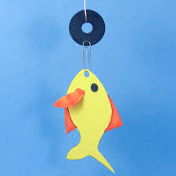
- You could also make fish by cutting out fish shapes and attaching paper clips to them. How many fish can you catch with your rod? The fish could have words on them for you to read or number sentences to work out?

Explore Floating and Sinking
● Fill up a bowl, sink or basin and collect a range of objects to explore. Which ones float and which sink? Why do you think they float/ sink?
CHALLENGE: Keep a record of the objects that float and sink? This could be using pictures or written

Make your own under the sea scene
Can you use paints, crayons, coloured paper, other arts and craft bits to create a scene? Maybe you could use grass for seaweed and stones or shells too.

The little Mermaid
https://www.youtube.com/watch?v=24JS0gjS5RM
Follow the link and learn a dance to the little Mermaid song ‘Under the Sea’

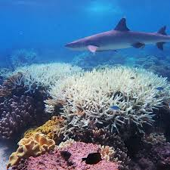
Great Barrier Reef
Can you find out about the great Barrier reef and create a poster about it? Think about the marine life, threats to it and tourism.

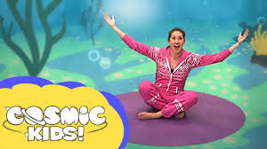
Seaside Yoga
https://www.youtube.com/watch?v=LhYtcadR9nw
Take part in squish the fish with cosmic yoga.

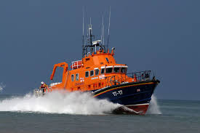
RNLI
https://rnli.org/youth-education/education-resources/online-learning

There are some lovely games and ideas from the Royal National Lifeboat Institution on this link.

Under the sea counting
https://www.topmarks.co.uk/learning-to-count/underwater-counting
Can you count the sea creatures and find the matching number?
What is 1 more or less than the number you counted?

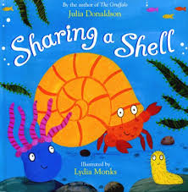
Sharing a Shell
Watch the online storybook- ‘Sharing a shell’ https://www.youtube.com/watch?v=6KuSl9eXgpk
Discuss how the crab felt in the story at each stage. You could write words or draw a picture to represent the crab’s feelings.

A sailor went to sea song

https://safeyoutube.net/w/Msh6
Can you learn the song? Maybe you could record yourself singing it and post it on tapestry.

