Learning Project: Summer Term Week 6 (18.5.20) – Food

The project this week aims to provide opportunities for your child to learn more about food. Learning may focus on where different foods originate from, what makes a healthy meal and opportunities to cook.

The activities for this project are designed for the whole family. We do not expect you to complete all of the activities. Please choose the activities that interest your family and complete these throughout the week. If you would like to share this learning with your teacher then you can upload it onto Tapestry, Purple Mash or email it to school.

You can also continue to contact your teacher through Purple Mash, Tapestry and e-mail.

This symbol shows that the activity has been set and can be handed in on
Purple Mash (although you can use paper/card instead if you prefer).

Please look at Tapestry, Purple Mash and the school website for English and Maths activities.

Activities:
Fruit and vegetables - Draw pictures of fruit and vegetables in your house. Label the fruit and vegetables and place in alphabetical order.

Fruit and vegetable quiz
Can you sort out the fruits and vegetables?

Design a poster Think about the foods you like to eat and food that you need to eat to keep you healthy. Create a poster that you can put in the kitchen or in the school hall. Will you be able to use any food wrappers or make your poster interactive?

Healthy lunchbox: Can you play this game and make a healthy lunchbox?

Traditional food: Many cultures have various dishes of food to celebrate their festivals. Find out about a festival and compare it to a different festival. What are the similarities? What are the differences? How is the food prepared? Do you have any traditional food you enjoy with your family?

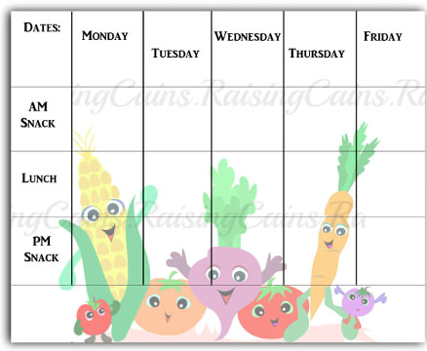
Restaurant: Can you plan a menu? Think about what you would like to have on your menu. Can you design a menu for a vegetarian? Can you design a menu for a vegan? Will you have options on your menu for people who have allergies?
Look around the house for any leaflets or take away menus.
What price is the food? Can you do any meal deals?

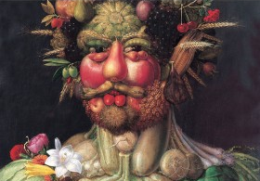
Look at the work of Giuseppe Arcimboldo.
Using different drawing materials, can you create a picture of your own?
Fruit survey: ask in your family the different fruits they like to eat. Collect the information and add it to your tally chart. Can you represent this information in a particular way? Example Tally chart available on twinkl.
https://www.twinkl.co.uk/resource/t-or-63-carrot-club-favourite-vegetable-tally-chart-activity-sheet
Favourite fruit
Can you draw or choose a picture of your favourite fruit and write about it?

Cooking: find a few recipes and check if you have the ingredients at home and cook a meal with your family. Think about a starter, main and dessert. Who will do the measuring?

Healthy/ Unhealthy-
Provide your child with a selection of items from your kitchen cupboards. Can they sort them into things that are healthy and unhealthy? Discuss why the food is good or bad for you. Look at the Eatwell plate to help figure out which foods they should eat a lot of or not very much of.

Discuss how exercise is an important part of staying healthy. Watch and complete a 10 minute shake up.

Healthy mind
Here are some ideas for children’s wellbeing.
https://www.thelilyjoproject.com/2020/03/18/5-activities-to-look-after-your-childs-mental-well-being-in-covid-19-outbreak/
5 a day
Support your child to create a food diary to record how many pieces of fruit and vegetables they eat in a day. They could write these using their phonics knowledge or draw a picture of each item.

Play shops
Using toy food or old packaging, set up a food shop for your child to act out being the shopkeeper and customer. You could introduce coins to support their developing knowledge of money. Give them a notepad to use as a shopping list to encourage writing for a purpose.

Potato / veg printing
Using a selection of vegetables available in your kitchen, support your child to print and explore the shapes and patterns created:
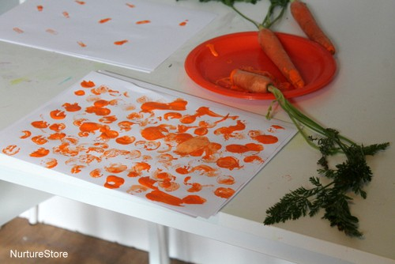
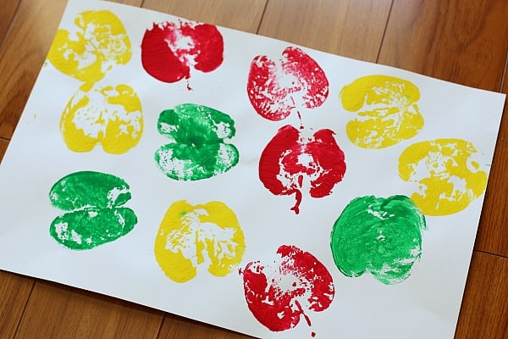
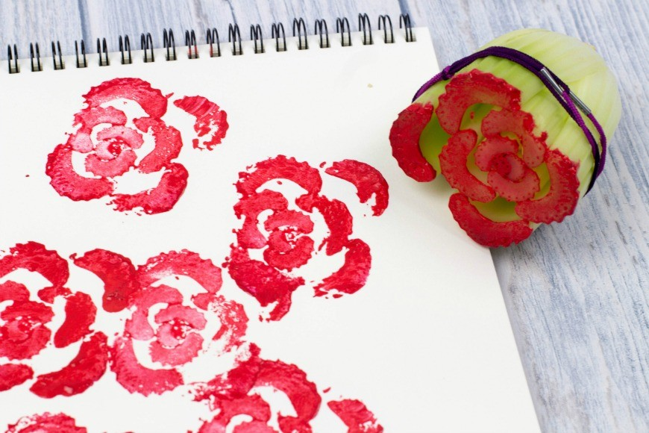

Cornflour gloop
Mix cornflour with a small amount of water in a mixing bowl. It will make a slimy, stretchy mixture. Allow your child to explore the change of texture from wet to dry and the texture of the gloop.
Fruit Bowl
Can you draw a bowl of fruit? You could choose to do an observational drawing of a fruit bowl or create one on purple mash.

Fruit fall
Can you catch the farmer’s fruits in a basket? How many did you catch? What can you tell someone about the results in the graph?
http://toytheater.com/fruit-fall/

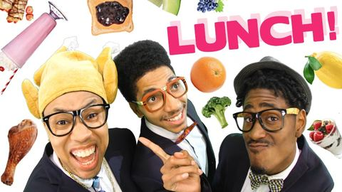
Gonoodle
Stay active.
Watch and copy the gonoodle action dance about lunch.

https://family.gonoodle.com/activities/lunch

Instruction writing
Write a set of instructions for making toast. Can they use imperative verbs? (bossy words e.g put, cut, spread)

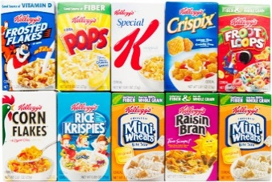
Designing a label
Design a new label for a cereal box.
What eye catching information will you add?
Can you use an exclamation mark?

