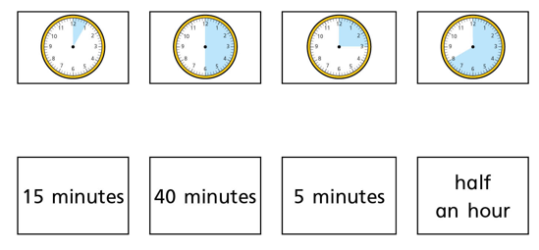
Can you match the durations of time shown on the clocks to the written duration of time?
Can you show me what 35 minutes would look like on the clock face below?
(Shade 35 minutes).
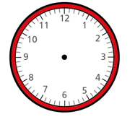

Tick the clocks that show a 30 minute duration.
What do you notice?
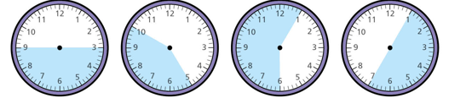

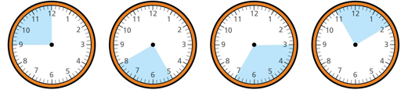
Tick the clocks that show a 15 minute duration.

Miss Woodhouse sat down to read her book at quarter past 1.
She was reading her book for 20 minutes.
Draw the hands on the clock to show the time Miss Woodhouse finished reading.
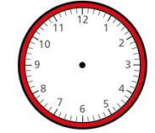

Miss Justice put some cookies in the oven at Half past 4.
The cookies baked for 35 minutes.
Draw the hands on the clock to show the time the cookies were finished baking.

The Year 2 children went into the hall for assembly at 10 past 2.
The assembly lasted half an hour.
Draw the hands on the clock to show what time the assembly finished.

Can you complete the table below to show the duration of time it took each child to get to school?
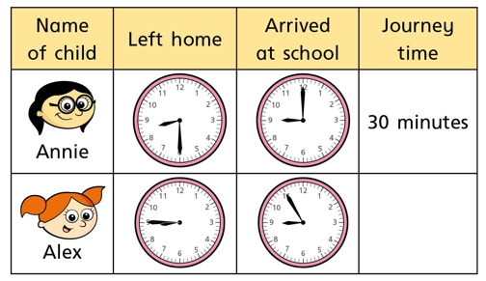
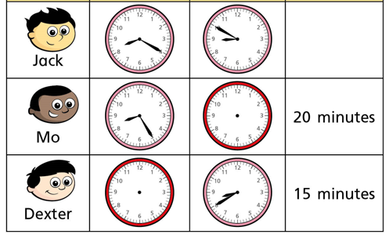

True or false x
- Annie arrived at school first
- Jack left home first
- Mo and Dexter left home at the same time
- Annie left home before Jack
- Alex arrived at school after Jack

