Friday 27th March 2020.
Multiplication and division fact families.

Can you use the numbers below to create your own fact families? This first one is done for you.
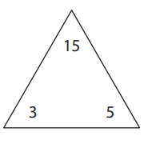
3 x 5 = 15
5 x 3 = 15
15 ÷ 3 = 5
15 ÷ 5 = 3
