Our Environment – Wind Farms
Click this link to learn a bit about wind farms and what wind turbines are.
https://www.bbc.co.uk/bitesize/clips/ztgd2hv
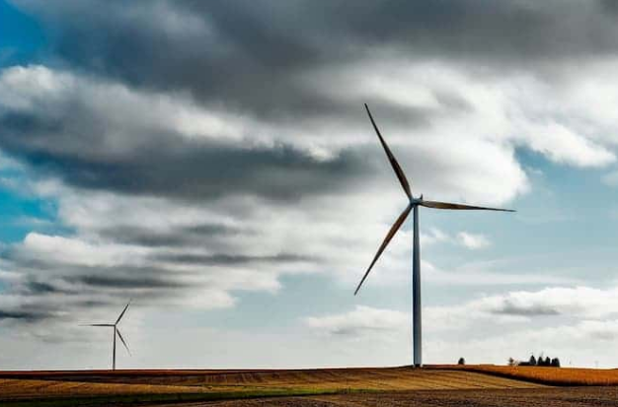

More information:
Wind farms are areas where many large wind turbines have been grouped together. They “harvest” the power of the wind. These large turbines look a bit like super-tall windmills. A large wind farm can have hundreds of wind turbines spread out over hundreds of miles.
People like wind farms because it is a ‘clean’ source of power (this means that there isn’t any pollution or chemicals from them in our air like when we use coal or oil). Wind is also free so once the wind turbine is installed, it doesn’t cost anything. Wind turbines can give power to hundreds of homes. Also, wind turbines that are installed on farming land can be a source of income for the farmers as they the wind farm owners can make payments to the farmers for use of their land.
However, there are some people who are against wind turbines. They think they are an eye sore on the landscape (especially if the wind isn’t blowing and they are just sat there still!). Unfortunately wind turbines are also dangerous for birds – if a bird flies too close they can be killed from the blades. Also, they are very expensive to install but at least when they are up then all that needs to happen is the wind to blow.
Words or phrases you might want to discuss the meaning of with a grown-up to help your understanding:
harvest, source of power, pollution, installed, source of income, eye sore, landscape, expensive
Think about the points above and have a conversation with your grown-ups about wind farms. What are their thoughts on them? What do you think about them? Do you have a wind farm near you? Is there a way you could make the wind farms better? You might want to write down some notes.
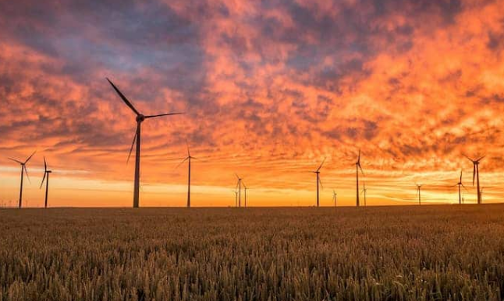
Tomorrow we will be doing a piece of writing based on a story clip about wind farms so if you want to carry out any more research it might help you.

