Part-part-whole models:
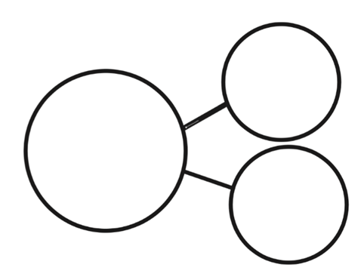

Five frame:

Ten frame:

