Hello Maple and Willow. It’s time to decide what your magic potion will do and what ingredients you need. Good luck, everyone!



**My magic potion will** _________________________________________________________________  
  
  
__________________________________________________________________________________________________

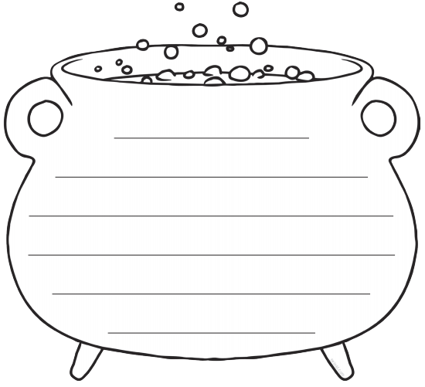

**I will need…**

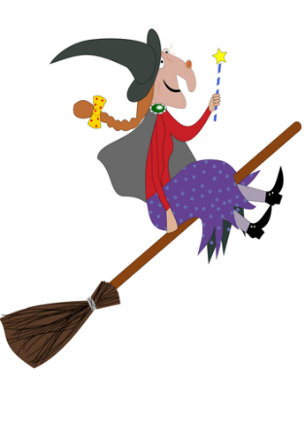

What magic words will you use when you are saying your spell?