Today we will be focusing on describing turns and will be using the vocabulary clockwise and anti-clockwise. I wonder if you are already familiar with this vocabulary…

With a figure or a real person, we would like you to become familiar with these turns:
Full turn clockwise/anticlockwise
Half turn clockwise/anti-clockwise
Quarter turn clockwise/anti-clockwise
Three quarter tur clockwise/anti-clockwise
You could guide your partner on a trail around the house or garden using the language learnt yesterday and today.

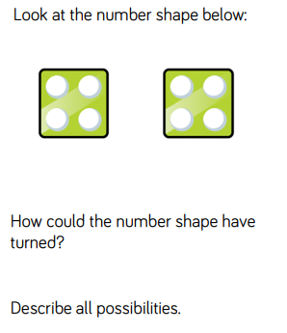
Challenge:

