Use the vocabulary up, down, left, right to complete the stem sentences.
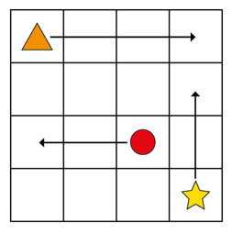

The star is moving ____ squares _____
The circle is moving _____ squares ____
The triangle is moving ____ squares ____

When it is obvious which way a person/object is facing we can use the vocabulary ‘forwards’ and ‘backwards’ to describe their movement.
Use the vocabulary forwards, backwards to complete the stem sentences.

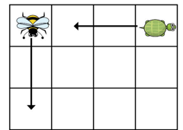
The bee is moving ___ squares _____
The tortoise is moving _____ squares ______

Using the vocabulary forwards, backwards, left, right direct someone in your family around the house or garden. They have to listen carefully to your directions. Take it in turns so that you have a go at following the directions too!

