COVID-19 school closure arrangements for Safeguarding and Child Protection at Robert Miles Infant School.

Robert Miles Infant School

Policy owner: Nova Education Trust

Date: 5th January 2020
Date shared with staff: 8th Jan 2021

1. Context

From 5th January 2021 parents were asked to keep their children at home, wherever possible, and for schools to remain open only for those children of workers critical to the COVID-19 response - who absolutely need to attend and for children who are vulnerable. All other pupils will be taught through remote learning packages, which may include Live streaming of lessons, learning packs and pre-recorded sessions.

This addendum of the Robert Miles Infant School Safeguarding, and Child Protection policy contains details of our individual safeguarding arrangements in the following areas:

1. Context 2
- Vulnerable children & RAG 3/4
- Attendance monitoring 4
- Designated Safeguarding Lead 5
- Reporting a concern 5
- Safeguarding Training and induction 6
- Safer recruitment/volunteers and movement of staff 7
- Online safety in schools and colleges 7
- Children and online safety away from school and college 7
- Supporting children not in school 8
- Supporting children in school 9
- Peer on Peer Abuse 9
- Support from the Multi-Academy Trust 10
- Mental Health ………………………………………………………………………..10
- DFE Checklist ………………………………………………………………………11/12
- Appendix 1 – online safety ……………………………………………………13-15

Key contacts

Role | Name | Contact number | Email
Designated Safeguarding  Lead | Linda Barbuti | 01949  837422/07950 926553 | lbarbuti@rmischool.co.uk
Deputy Designated  Safeguarding Lead | Sally Marshall | 01949  837422 | smarshall@rmischool.co.uk
Headteacher | Linda Barbuti | 01949  837422 | lbarbuti@rmischool.co.uk
Trust Safeguarding  Manager | Helen Duffy | 07701 008067 | hduffy@novaeducationtrust.net
Chair of Governors | Melanie Modare |  | mmodare@novagovernor.net
Safeguarding Trustee

Vulnerable children
Vulnerable children and young people include those who:
- are assessed as being in need under section 17 of the Children Act 1989, including children and young people who have a child in need plan, a child protection plan or who are a looked-after child
- have an education, health and care (EHC) plan
- have been identified as otherwise vulnerable by educational providers or local authorities (including children’s social care services), and who could therefore benefit from continued full-time attendance, this might include:
  - children and young people on the edge of receiving support from children’s social care services or in the process of being referred to children’s services
  - adopted children or children on a special guardianship order
  - those at risk of becoming NEET (‘not in employment, education or training’)
  - those living in temporary accommodation
  - those who are young carers
  - those who may have difficulty engaging with remote education at home (for example due to a lack of devices or quiet space to study)
  - care leavers
  - others at the provider and local authority’s discretion including pupils and students who need to attend to receive support or manage risks to their mental health

Senior leaders, especially the Designated Safeguarding Lead (and deputy) know who our most vulnerable children are. They have the flexibility to offer a place to those on the edge of receiving children’s social care support.

Robert Miles Infant School will continue to work with and support children’s social workers to help protect vulnerable children. This includes working with and supporting children’s social workers and the local authority virtual school head (VSH) for looked-after and previously looked-after children. The lead person for this will be: Linda Barbuti

There is an expectation that vulnerable children who have a social worker will attend an education setting, so long as they do not have underlying health conditions that put them at risk. In circumstances where a parent does not want to bring their child to an education setting, and their child is considered vulnerable, the social worker and Robert Miles Infant School will explore the reasons for this directly with the parent.

Where parents are concerned about the risk of the child contracting COVID19, DSL or the social worker will talk through these anxieties with the parent/carer following the advice set out by Public Health England.

Robert Miles Infant School will encourage our vulnerable children and young people to attend a school, including remotely if needed.

Risk and RAG rating pupils:
At Robert Miles Infant School pupils who are deemed to be vulnerable will be RAG rated according to the following criteria:

Red – pupils most at risk of harm i.e Child Protection Plan
Amber – moderate risk, i.e Child in Need
Green – some concerns

Contact if not on site;

Pupils in red, who are our most vulnerable students, should have correspondence from school at least once/twice per week (email/phone call) and should be discussed with the SDSL or DSL weekly (regularity of calls to be defined by the safeguarding team in school depending on the individual needs of the pupil/family).

Pupils in amber should have one call home/ email weekly and should be discussed with the SDSL or nominated DSL weekly.

Green students should be monitored at the discretion of the safeguarding team.
It is for the Head of School to identify who is the most appropriate person to make the call, this may be the class teacher, a DSL, Head of Department etc…

Attendance monitoring

The DfE are asking educational settings for information about pupil or student attendance and setting closures or partial closures during coronavirus (COVID-19), daily by 2pm.
Use this service to report:
· whether your setting is open
· numbers of vulnerable children and children of critical workers attending
· remote education arrangements
· free school meals arrangements
· staff absences
This data is being collected to help manage the impact of and response to coronavirus (COVID-19) on the education sector. The information supply helps the department and other government bodies make decisions.

Attendance recording in schools
As vulnerable children are still expected to attend school full time, they should not be marked as Code X if they are not in school (except if they are shielding, self-isolating or quarantining). Schools and colleges should encourage vulnerable children to attend but if the parent of a vulnerable child wishes their child to be absent from school, the parent should let the school know that the pupil will not be attending. The Department for Education expects schools and colleges to grant such applications for leave given the exceptional circumstances. This should be recorded as code C (leave of absence authorised by the school) unless another authorised absence code is more applicable.
As with vulnerable children, critical worker parents and carers should let schools know if their child will not be attending and, if not, schools should grant a leave of absence (code C) given the exceptional circumstances.

All pupils who are not expected to be in school should be marked as Code X. They are not attending because they are following public health advice.

Robert Miles Infant School and social workers will agree with parents/carers whether children in need should be attending school – Robert Miles Infant School will then follow up on any pupil that they were expecting to attend, who does not. Robert Miles Infant School will also follow up with any parent or carer who has arranged care for their child(ren) and the child(ren) subsequently do not attend.

To support the above, Robert Miles Infant School will, when communicating with parents/carers and carers, confirm emergency contact numbers are correct and ask for any additional emergency contact numbers where they are available.
In all circumstances where a vulnerable child does not take up their place at school, or discontinues, Robert Miles Infant School will notify their social worker.

Designated Safeguarding Lead
Robert Miles Infant school has a Designated Safeguarding Lead (DSL) and a Deputy DSL.
The Designated Safeguarding Lead is: Linda Barbuti
The Deputy Designated Safeguarding Lead is: Sally Marshall

The optimal scenario is to have a trained DSL (or deputy) available on site. Where this is not the case a trained DSL (or deputy) will be available to be contacted via phone or online video - for example when working from home.

Where a trained DSL (or deputy) is not on site, in addition to the above, a senior leader or designated staff member will assume responsibility for co-ordinating safeguarding on site.

This might include updating and managing access to safeguarding app and liaising with the offsite DSL (or deputy) and as required liaising with children’s social workers where they require access to children in need and/or to carry out statutory assessments at the school or college.

It is important that all Robert Miles Infant School staff and volunteers have access to a trained DSL (or deputy). On each day staff on site will be made aware of that person is and how to speak to them. This also remains the case where there is a hub of schools working together.

The DSL will continue to engage with social workers, and attend all multi-agency meetings, which can be done remotely.

Reporting a concern
Where staff have a concern about a child, they should continue to follow the process outlined in the school Safeguarding Policy, this includes making a report via the safeguarding app, which can be done remotely.

In the unlikely event that a member of staff cannot access the app from home, they should email the Designated Safeguarding Lead or Head teacher. This will ensure that the concern is received.
Staff are reminded of the need to report any concern immediately and without delay.
Where staff are concerned about an adult working with children in the school, they should report the concern to the head teacher. If there is a requirement to make a notification to the head teacher whilst away from school, this should be done verbally and followed up with an email to the head teacher.

Concerns around the Head teacher should be directed to the Chair of Governors: Melanie Modare/Helen Duffy.

The Multi-Academy Trust will continue to offer support in the process of managing allegations and Helen Duffy Safeguarding Lead should be contacted either via email : hduffy@novaeducationtrust.net or by phone, 07701 008067, in the event of not being able to contact her directly, please call Dave Hooker on 07711 350579.

Safeguarding Training and induction
DSL training is very unlikely to take place face to face whilst there remains a threat of the COVID 19 virus, alternative on-line sessions are available online and should be booked onto when required.

For the period COVID-19 measures are in place, a DSL (or deputy) who has been trained will continue to be classed as a trained DSL (or deputy) even if they miss their refresher training due to availability of sessions.

All existing school staff have had safeguarding training and have read part 1 of Keeping Children Safe in Education (2020). The DSL should communicate with staff any new local arrangements, so they know what to do if they are worried about a child.

Where new staff are recruited, or new volunteers enter Robert Miles Infant School, they will continue to be provided with a safeguarding induction.

If staff are deployed from another education or children’s workforce setting to our school, we will take into account the DfE supplementary guidance on safeguarding children during the COVID-19 pandemic and will accept portability as long as the current employer confirms in writing that:-
- the individual has been subject to an enhanced DBS and children’s barred list check
- there are no known concerns about the individual’s suitability to work with children
- there is no ongoing disciplinary investigation relating to that individual

For movement within the Trust, schools should seek assurance from the Multi- Academy Trust (MAT) HR Manager that the member of staff has received appropriate safeguarding training.
Upon arrival, they will be given a copy of the receiving setting’s child protection policy, confirmation of local processes and confirmation of DSL arrangements.

Safer recruitment/volunteers and movement of staff

It remains essential that people who are unsuitable are not allowed to enter the children’s workforce or gain access to children. When recruiting new staff, Robert Miles Infant School will continue to follow the relevant safer recruitment processes for their setting, including, as appropriate, relevant sections in part 3 of Keeping Children Safe in Education (2020) (KCSIE).

In response to COVID-19, the Disclosure and Barring Service (DBS) has made changes to its guidance on standard and enhanced DBS ID checking to minimise the need for face-to-face contact.

Where Robert Miles Infant School are utilising volunteers, we will continue to follow the checking and risk assessment process as set out in paragraphs 167 to 172 of KCSIE. Under no circumstances will a volunteer who has not been checked be left unsupervised or allowed to work in regulated activity.

Robert Miles Infant School will continue to follow the legal duty to refer to the DBS anyone who has harmed or poses a risk of harm to a child or vulnerable adult. Full details can be found at paragraph 163 of KCSIE.

Robert Miles Infant School will continue to consider and make referrals to the Teaching Regulation Agency (TRA) as per paragraph 166 of KCSIE and the TRA’s ‘Teacher misconduct advice for making a referral.

During the COVID-19 period all referrals should be made by emailing Misconduct.Teacher@education.gov.uk

Whilst acknowledging the challenge of the current National emergency, it is essential from a safeguarding perspective that any school is aware, on any given day, which staff/volunteers will be in the school or college, and that appropriate checks have been carried out, especially for anyone engaging in regulated activity. As such, Robert Miles Infant School will continue to keep the single central record (SCR) up to date as outlined in paragraphs 148 to 156 in KCSIE.

Online safety in schools and colleges

Robert Miles Infant School will continue to provide a safe environment, including online. This includes the use of an online filtering system.

Where students are using computers in school, appropriate supervision will be in place.

Children and online safety away from school and college

It is important that all staff who interact with children, including online, continue to look out for signs a child may be at risk. Any such concerns should be dealt with as per the Child Protection Policy and where appropriate referrals should still be made to children’s social care and as required, the police.

Online teaching should follow the same principles as set out in the MAT code of conduct for remote learning (appendix 1.)

Robert Miles Infant School will ensure any use of online learning tools and systems is in line with privacy and data protection/GDPR requirements.

One to one contact with Students:
In light of changes to government guidance, pupils may have face to face time with tutors, Heads of Department and Pastoral teams. Where possible this meeting should occur in school in a designated area for both parties.

If a pupil is not available to attend the school site then a staff member may conduct an online session. The staff member must:
- Arrange the meeting with the parent
- The parent must be invited to attend the meeting to safeguard both the child and staff member
- Meetings must be recorded

In addition:

- Staff and children must wear suitable clothing, as should anyone else in the household.
- Any computers used should be in appropriate areas, for example, not in bedrooms; and the background should be blurred.
- The live class should be recorded so that if any issues were to arise, the video can be reviewed.
- Live classes should be kept to a reasonable length of time, or the streaming may prevent the family ‘getting on’ with their day.
- Language must be professional and appropriate, including any family members in the background.
- Staff must only use platforms provided by Nova Education Trust to communicate with pupils

Supporting children not in school

Robert Miles Infant School is committed to ensuring the safety and wellbeing of all its Children and Young people.

Where the DSL has identified a child to be on the edge of social care support, or who would normally receive pastoral-type support in school, they should ensure that a robust communication plan is in place for that child or young person.

Details of this plan must be recorded on the safeguarding app, as should a record of contact have made.

The communication plans can include; remote contact, phone contact, door-step visits. Other individualised contact methods should be considered and recorded via the app.

Robert Miles Infant School and its DSL will work closely with all stakeholders to maximise the effectiveness of any communication plan.

This plan must be reviewed regularly (at least once a fortnight) and where concerns arise, the DSL will consider any referrals as appropriate.

The school will share safeguarding messages on its website and social media pages.

Robert Miles Infant School recognises that school is a protective factor for children and young people, and the current circumstances, can affect the mental health of pupils and their parents/carers. Teachers at Robert Miles Infant School need to be aware of this in setting expectations of pupils’ work where they are at home.

Robert Miles Infant School will ensure that where we care for children of critical workers and vulnerable children on site, we ensure appropriate support is in place for them. This will be bespoke to each child and recorded on the app.

Supporting children in school

Robert Miles Infant School is committed to ensuring the safety and wellbeing of all its students.

Robert Miles Infant School will continue to be a safe space for all children to attend and flourish. The Headteacher will ensure that appropriate staff are on site and staff to pupil ratio numbers are appropriate, to maximise safety.

Robert Miles Infant School will refer to the Government guidance for education and childcare settings on how to implement social distancing and continue to follow the advice from Public Health England on handwashing and other measures to limit the risk of spread of COVID19.

Robert Miles Infant School will ensure that where we care for children of critical workers and vulnerable children on site, we ensure appropriate support is in place for them. This will be bespoke to each child and recorded on the app.

Where Robert Miles Infant School has concerns about the impact of staff absence – such as our Designated Safeguarding Lead or first aiders the Head will discuss them immediately with the trust.

Peer on Peer Abuse

Robert Miles Infant School recognises that during the closure a revised process may be required for managing any report of such abuse and supporting victims.

Where a school receives a report of peer on peer abuse, they will follow the principles as set out in the KCSIE and of those outlined within of the Child Protection Policy.

The school will listen and work with the young person, parents/carers and any multi- agency partner required to ensure the safety and security of that young person.

Concerns and actions must be recorded on the safeguarding app and appropriate referrals made.

Support from the Multi-Academy Trust

The Multi-Academy Trust (MAT) Central Safeguarding Team, Helen Duffy, Ash Rahman and Dave Hooker will provide support and guidance as appropriate to enable the DSL to carry out their role effectively.
This includes, remotely accessing Child Protection files for the purpose of quality assurance, support, guidance and direction.

The MAT will also provide regular group and/or individual supervision sessions for leaders. This may take the form of an online meeting.

Mental health
Negative experiences and distressing life events, such as the current circumstances, can affect the mental health of children and their parents. Where they have children of critical workers and vulnerable children on site, and/or more children working remotely at home, schools and colleges should ensure appropriate support is in place for them.
Guidance on mental health and behaviour in schools (which may also be useful for colleges) can help schools to identify children who might need additional support, and to put this support in place. The guidance sets out how mental health issues can bring about changes in a child’s behaviour or emotional state which can be displayed in a range of different ways, all of which could be an indication of an underlying problem. This can include for example being fearful or withdrawn; aggressive or oppositional; or excessive clinginess. Support for pupils and students in the current circumstances can include existing provision in the school or college (although this may be delivered in different ways, for example over the phone for those children still not attending provision) or from specialist staff or support services.

Teachers should be aware of the impact the current circumstances can have on the mental health of those students/pupils (and their parents) who are continuing to work from home, including when setting expectations of childrens’ work. The department has provided separate guidance on remote education practices during the coronavirus outbreak.

DfE Checklist:
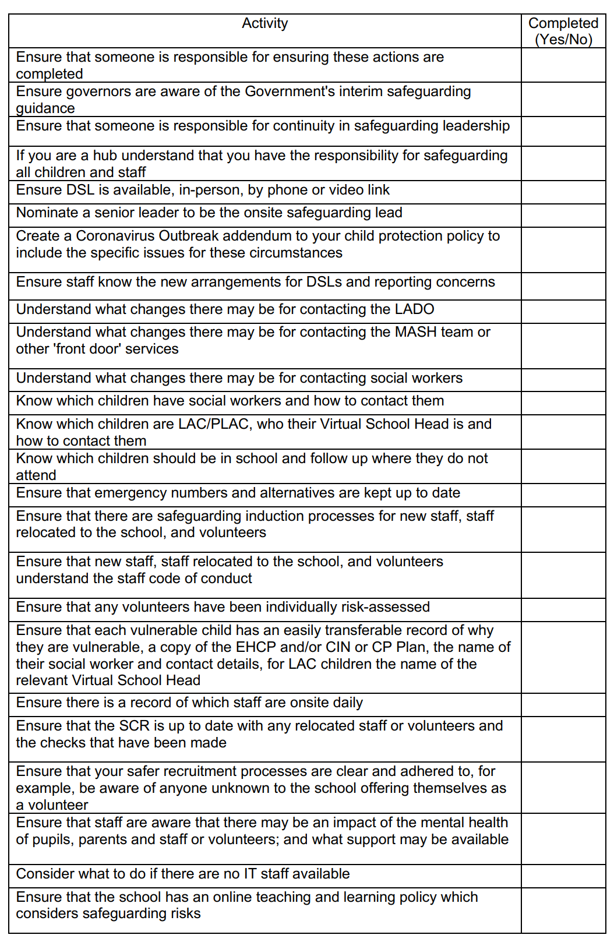
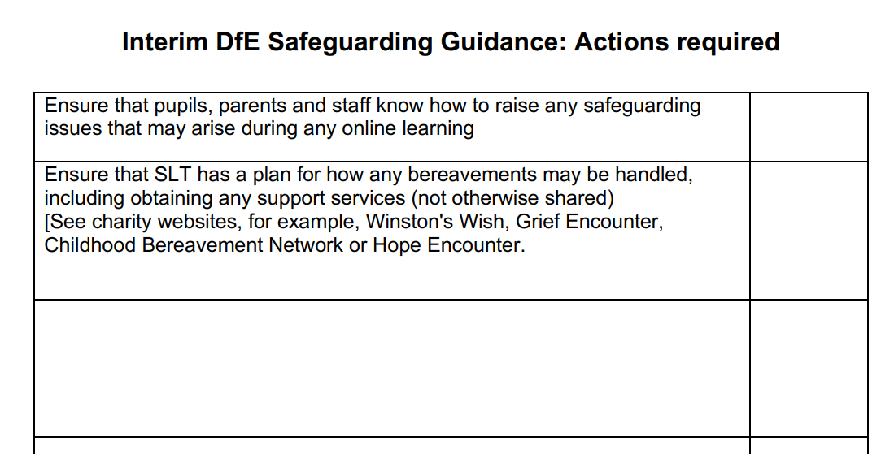

Appendix 1 – Online safety
Use of Microsoft TEAMs during the COVID 19 epidemic

Recent experience has shown that a number of different scenarios may occur when a single or multiple COVID case is confirmed in a school. It is most likely that individual or small groups of teaching staff may need to isolate and groups of pupils within a bubble will need to isolate. The PHE/DfE advice is to keep the school/bubble open to as many pupils as possible and it is unlikely that a whole bubble will be sent home.

In light of staff needing to quarantine and bubbles of pupils being closed down, the following must be used at both Primary and Secondary in regard to the use of Microsoft Teams for the delivery of material to pupils. This document covers the following scenarios:

Staff member isolating – pupils on site
Staff member isolating- pupils isolating
Staff member at school – partial closure
Staff member at school – full bubble closure
Full lockdown

Staff member needing to Isolate whilst pupils on site:
Where a staff member is required to isolate, due to a positive test or awaiting results and well, delivery to pupils is still expected. The staff member can stream from home to a class in school via Microsoft Teams. In this circumstance the following protocols must be adhered to:

-The staff member must be dressed in professional wear.
-The staff member must use the background setting in TEAMs to create a blank canvas.
- A CLA/TA/ member of support staff must be present to supervise the class in school at all times.
- Language must be professional and appropriate.
- Staff should record, the length, time, date and attendance of any sessions held on a timetable.
- Lessons should only take place at normal timetabled time.
- The lesson should end to all pupils at the same time and no extension/support activity should carry on after a lesson has ended.

Staff member at school – full bubble and partial bubble closure:
Where a bubble is closed down or partially closed, a staff member can stream a live lesson to pupils, providing that:

- Where possible the staff member is on school site (if not, ensure measures below).
- Where possible 2 adults should be in the group. The staff member MUST be present on TEAMS 5 minutes before the first child enters and be the last to leave the session. This will be the teacher and a member of the support staff team.
- The Lobby system MUST be set up, this way if one staff member has to leave or the internet causes issues, then pupils can return to the lobby area whilst issues are addressed.
- The session must be recorded using the built-in recording function on Teams and stored for at least 365 days - https://support.microsoft.com/en-us/office/record-a-meeting-in-teams-34dfbe7f-b07d-4a27-b4c6-de62f1348c24
- The staff members must be dressed in professional wear
- The staff member/s must use the background setting in TEAMs to create a blank canvas
- Parents must be informed prior to the sessions taking place via a timetable. Where a timetable needs to be amended at short notice then the school MUST inform the pupil/parent via XXXX school system.
- Pupils must wear suitable clothing, as should anyone else in the household.
- Any computers used should be in appropriate areas, for example, not in bedrooms; and the background should be blurred if possible.
- Live teaching sessions should be kept to a reasonable length of time (impact of possible timetable changes) and no more than an hour.
- Language must be professional and appropriate.
- Staff must only use platforms provided by Nova Education to communicate with pupils.
- Staff should record, the length, time, date and attendance of any sessions held (School specific decision)

*SLT MUST sample sessions for all teaching staff to check what is happening meets the criteria.

In the event of full lock down:
Where a full lock down is imposed, Nova Education Trust will support a comprehensive of delivery to pupils ensuring that:

- Where possible 2 adults should be in the group, this is based upon DfE good practice guidance. The staff member MUST be present on TEAMS 5 minutes before the first child enters and be the last to leave the session.
- A timetable of sessions must be provided ideally a week in advance, so that pupils and families are aware. Where a timetable needs to be amended at short notice then the school MUST inform the pupil/parent via XXXX school system.
- A Lobby system MUST be set up, this way if one staff member has to leave or the internet causes issues, then pupils can return to the lobby area whilst issues are resolved.
- The session must be recorded using the built-in recording function on Teams and stored for at least 365 days - https://support.microsoft.com/en-us/office/record-a-meeting-in-teams-34dfbe7f-b07d-4a27-b4c6-de62f1348c24.
- The staff members must be dressed in professional wear.
- The staff member/s must use the background setting in TEAMs to create a blank canvas.
- Pupils must wear suitable clothing, as should anyone else in the household.
- Any computers used should be in appropriate areas, for example, not in bedrooms; and the background should be blurred if possible.
- The live meeting should be recorded so that if any issues were to arise, the video can be reviewed.
- Live teaching sessions should be kept to a reasonable length of time (impact of possible timetable changes) and no more than an hour.
- Language must be professional and appropriate, including any family members in the background.
- Staff must only use platforms provided by Nova Education to communicate with pupils.
- Staff should record, the length, time, date and attendance of any sessions held (School specific decision)

*SLT MUST sample sessions for all teaching staff to check what is happening meets the criteria.

School based systems to be developed
- How to inform parents of changes to timetabled sessions i.e. staff illness
- Stored files for 1 year
- How attendance of sessions and length will be recorded.
- QA of lessons – all staff need to checked on a cycle including SLT members

All the videos will be automatically recorded to Microsoft Steams, a video streaming service provided by Microsoft. Access to videos will be automatically limited to the member/s of the Team where the recording took place, students won’t be able to look through lessons they are not meant to be part of.

If accidently deleted, all videos go to a trust wide recycling bin where they are stored for 30 days. The director of IT will check the contents of this location every 2 weeks to ensure that no recordings are being deleted. If any are deleted, the director of IT will make the HoS aware so that the policy is reinforced.

Supporting documents: How to use Teams for a Live Lesson

DfE recommended guidance:

https://swgfl.org.uk/resources/safe-remote-learning/
https://www.lgfl.net/online-safety/resource-centre

