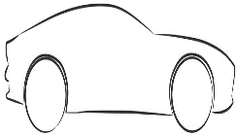
Speedy Words Assessment Name:

I can read these words by sight…
List 1 | List 2 | List 3 | List 4 | List 5 | List 6 | Other words
like | and | with | is | yes | do | old | there | anyone | every
the | your | you | on | of | be | call | by | over | watch
dog | go | to | come | no | big | this | many | some | who
I | dad | play | all | she | so | ball | now | once | small
my | look | he | it | we | then | does | how | away | tall
a | mum | can | house | are | her | any | down | what | house
cat | at | me | in | school | saw | see | one | going | name
 | they | was | for | said | went | here | where | why | friend

Please write the date and highlight it in the colour used for each assessment point:

